A close up of an animal

Description generated with high confidence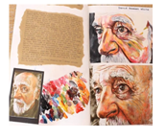

**Welcome to A Level Art**

**Holy Trinity School**

Now that you’ve decided to study Art at A Level, you’ll need to do a bit of preparation. This pack contains information regarding the course structure, the summer project, suggested equipment list and websites to prepare you to start your A level in September.

**The purpose of studying Art at A Level is to develop knowledge and understanding of:**

* *-Specialist vocabulary and artist terminology when analysing or explaining your own and others’ work*
* *-Theoretical research of a particular genre style and/or tradition*
* *-In-depth understanding of a variety of media, techniques and processes*
* *-Development of an idea, concept or issue*
* *-Recording ideas and observations related to chosen lines of enquiry*
* *-Communicating a particular meaning, message, idea or feeling*

**What do I have to do in A Level Art?**

There are two components of the course- the personal investigation and the externally set assignment. The table below summarises the evidence you will produce for each component:

|  |  |  |
| --- | --- | --- |
| **A Level Components** | **What will I need to do?** | **How will I evidence this?** |
| **Personal Investigation**  *(coursework)*  ***60%*** | -Create a body of work related to a chosen theme/s  -Create a final piece/s  -Write a personal study (essay) based on your chosen theme | --Exploration of a variety of media, techniques and processes  -Development of ideas in response to chosen artist/s/theme  -Recording of ideas and observations  A 1000-3000 word essay  -Research on a range of artists and/or designers |
| **Externally Set Assignment**  *(Exam)*  ***40%*** | -Create preparatory studies based on the theme  -Create a personal outcome/s in 15 hours of sustained focus | -By creating a body of work based on the theme given. This will include research, ideas, exploration of media, development of ideas and a final piece/s. |

The table below summarises tasks you will need to do to meet each objective:

|  |  |  |  |
| --- | --- | --- | --- |
| **Development of Ideas** | **Exploration of Media** | **Recording & Reflecting** | **Personal Response** |
| -Research a range of artists- collect images, make a visual study, include biographical information and analyse their artwork  -Create your own ideas inspired by your chosen artist/s  -Show a clear development of ideas- have they been manipulated, transformed and edited throughout the journey | -Explore with a wide variety of media, techniques and processes  -Continually review and refine your work- consider the potential and the limitations of the media used | -Take own photographs related to chosen theme/idea  -Create a range of observational studies from primary and secondary sources  -Use annotation to explain your idea/s and to reflect on your progress | -A final piece plan to document intentions for final piece and explanation  -A final piece/s that realises what you intended to do |

**A-Level Art at a glance**

* You will be given a starting theme and will respond to this in a variety of ways, some teacher guided, some that you come up with. We do 4 themes plus a mock exam.

You are assessed just as you were at GCSE:

* **Develop** - artist research,
* **Experiment** - with materials,
* **Record** - drawings and photos and
* **Present** – Final piece.

**We also ask that you equip yourself with the following:**

* A selection of drawing pencils-(B, 2B, 4B etc.)
* General stationery such as biros, rubbers, ruler etc.
* SD card for our digital cameras
* Masking tape
* Acrylic paint/Oil paint
* Watercolour palette or tin
* A selection of paintbrushes- (soft and stiff bristle)
* Pastels- soft/oil
* Soft coloured pencils or watercolour/Aquarelle
* Selection of pens- fine liners white and black
* Art palette
* Selection of paper- cartridge/textured/watercolour

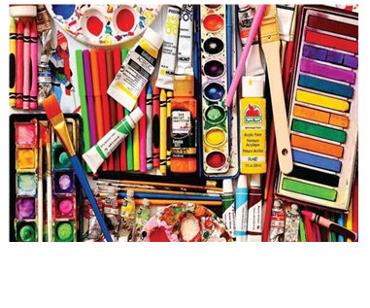

**Our best students use the 996 hours rule. These are the hours spent each two-week period for each subject:**

9 hours in class

9 hours of homework

6 hours of additional research and personal development

**Thinking before you start**

You need to think about the following:

* *What subject/ theme are you most passionate about?*
* *What is it about this subject that is interesting?*
* *What other avenues could this branch into?*
* *Will you be able to sustain this theme for a long period of time?*
* *Can you think of any particular artists that could relate to it?*
* *Are there any particular styles or techniques that you can explore with?*
* *Are there any current galleries, exhibitions or events that could be relevant?*
* *What places, objects or things could you collect or photograph?*

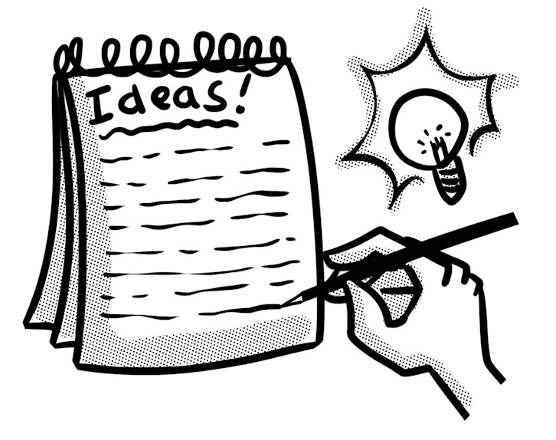

**Summer Project**

Over the holiday, you will need to complete the following tasks:

You will put in about 8-10 hours **effort** overall, sampling topics covered and **practise** some of the skills needed.

**Task 1**

**Drawings on a theme**

**Produce a series of art pieces in any material. Drawing, painting, collage, mixed media.**

**Choose one of these themes:**

**‘Still Life’, ‘Structures’ or ‘People’**

You must demonstrate in your unit of work that you have:

* **Explored** your ideas with a mind map –visual and written
* **Recorded** your experiences and observations (produce at least 3 sustained observational drawings and take a series of photographs – see suggestions below)
* Used a range of appropriate **materials and techniques**. Remember to think about working on different grounds e.g. watercolour wash, brown paper, tea stain etc...

**Task 2**

**Artist research**

Shown **connections** between your work and that of an artist

Research the work of 2 artists of your choice (see suggestions below) linking with your chosen theme

Collect and print images of their work.

Annotate the work and comment on :

* BACKGROUND: summarising the historical context, date of work and title
* CONTENT: Describe the composition—formal elements
* TECHNIQUE: Describe how it was made. How does this enhance the work?
* MOOD: Describe how it is intended to make the viewer feel...
* PERSONAL RESPONSE: What do you think and how could you use this to inspire your own practical work?

This work should all be shown on A3 papers or across sketchbook pages.

**Task 3**

**Artists Copies**

Find 2 artists that interest you- it could be their style, use of colour, materials they use etc. Document their work- a copy of their artwork, write some notes to explain it and include biographical information that is relevant. Use notes/annotations to support your work so far- this could include explanations or reflections.

**Task 4**

**Visit a gallery**

Visit a gallery or exhibition and document this- photos, drawing, notes, sketches, ticket etc.

**The Serpentine Gallery** (FREE) – Contemporary art

Kensington Gardens, London W2 3XA

<http://www.serpentinegalleries.org/>

**The Wallace Collection** (FREE) -18th century collection (for the more traditional and to see some impressive oil paintings)

Hertford House, Manchester Square, London, W1U 3BN

<http://www.wallacecollection.org/>

**The Victoria and Albert Museum** (FREE) – Art and design

Cromwell Rd, London SW7 2RL

<http://www.vam.ac.uk/>

**Saatchi Gallery** (FREE) – Contemporary art

Duke of York's HQ, King's Road, London, SW3 4RY

<http://www.saatchigallery.com/>

**The British Museum** – FREE

Great Russell Street, London, WC1B 3DG

<http://www.britishmuseum.org/>

**The Photographers Gallery** – Cost varies

16–18 Ramillies Street, London W1F 7LW

<http://thephotographersgallery.org.uk/>

**National Portrait Gallery** – FREE

St Martin’s Place, London, WC2H 0HE

<http://www.npg.org.uk/>

**Task 5**

**Taking Photos connected to your chosen theme**

Collect images and take photographs related to your theme-whole images, sections, close up etc.

Create a range of drawings and studies from these and life using a range of different materials and techniques-try as many different ones as possible. Create a variety of studies from your photos and try them in the style of your chosen artists- consider the artists style, technique and use of media etc.

**You can work on a sketchbook, or different sheets of paper (but remember it needs to fit into your A3 sized new sketchbook in September)**

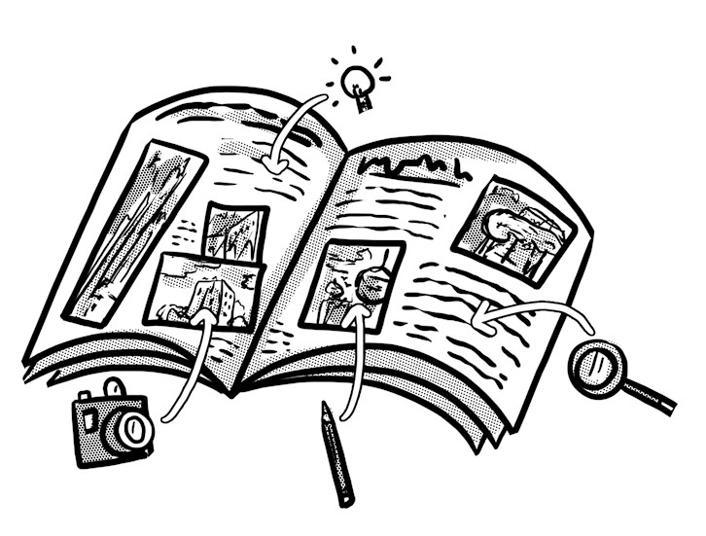

**Suggested Reading**

**Websites:**

<https://www.studentartguide.com/>

<https://www.theartnewspaper.com/>

<https://www.artforum.com/>

<http://www.artnews.com/>

http://artreport.com/

<http://www.tate.org.uk/art/artists/a-z>

<https://www.artsy.net/artists>

<https://artuk.org/discover/artists>

**TED Talks:**

<https://www.ted.com/talks/alexa_meade?language=en#t-262476> **Ted Talk by Alexa Meade- Your body is my canvas**

**Books:**

Thinking About Art: A Thematic Guide to Art History by Peter Huntsman (2015)

What Are You Looking At? 150 Years of Modern Art in the Blink of an Eye by Will Gompertz (2016)

Think Like an Artist by Will Gompertz (2015)

Looking at Pictures by Susan Woodford (2018)

The Art Book by Tom Melick (2014)

The Art of Creative Thinking by Rod Judkins (2015)

100 Artists’ Manifestos from the Futurists to the Stuckists by Alex Danchev (2011)

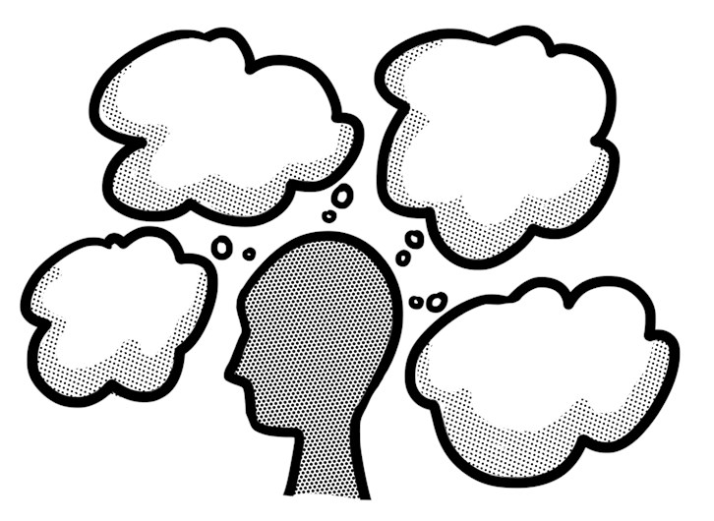

**Reading List Tasks:**

* List key terms and vocabulary- research meanings and/or context.
* Write a list of key questions and/or discussions points that are raised Collate notes about key subject matter, record quotes and any other relevant information.
* Create a visual mind map of key ideas. Use drawings, images and photographs to illustrate this

**Suggested Artists to investigate**

# Text BoxText Box Text Box

# **Paul Cézanne, Still Life with Skull, 1900**

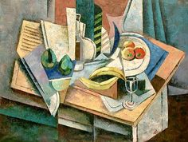

**Georges Braque**

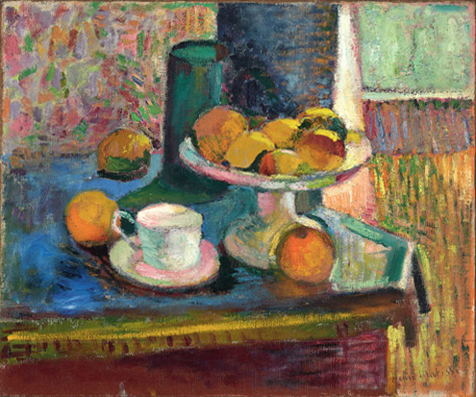

**Henri Matisse**

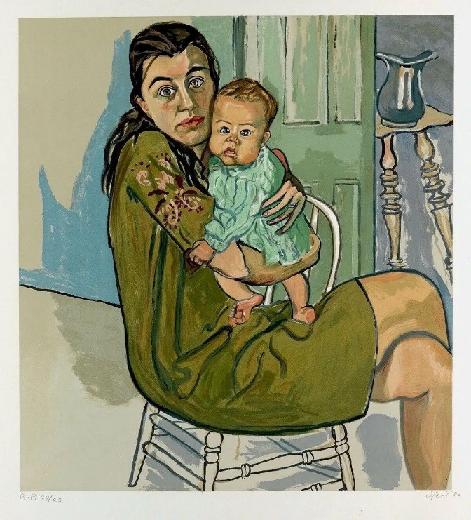

**Alice Neel**

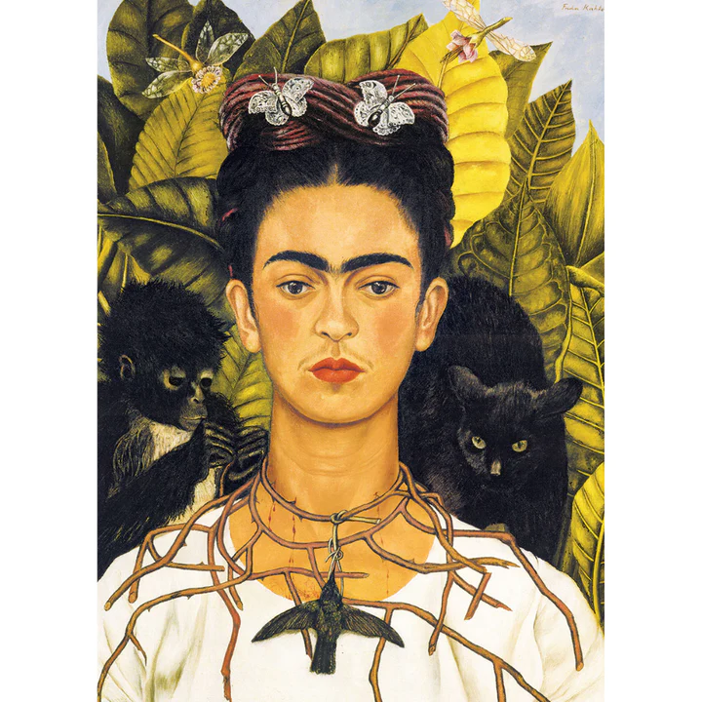

**Frieda Kahlo**

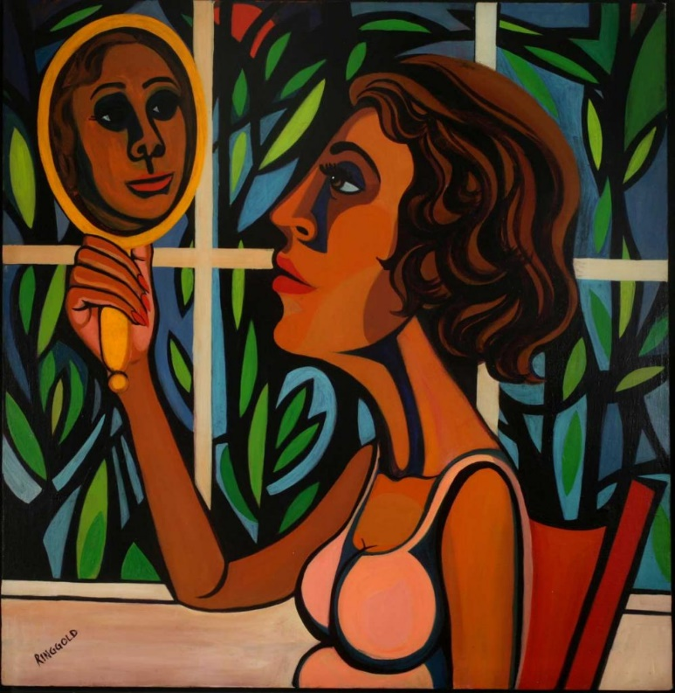

**Faith Ringold**  
  
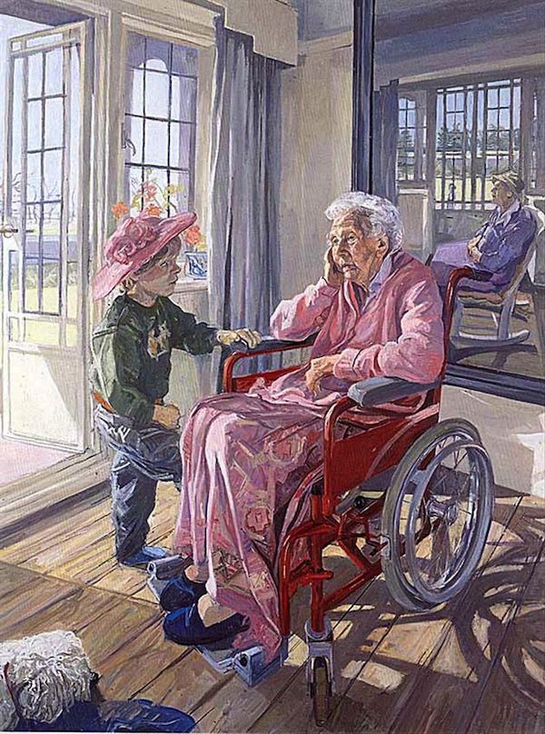

**John Wonnacott**

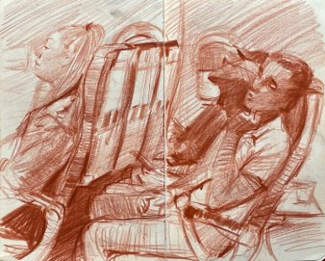

**Adebanji Alade**

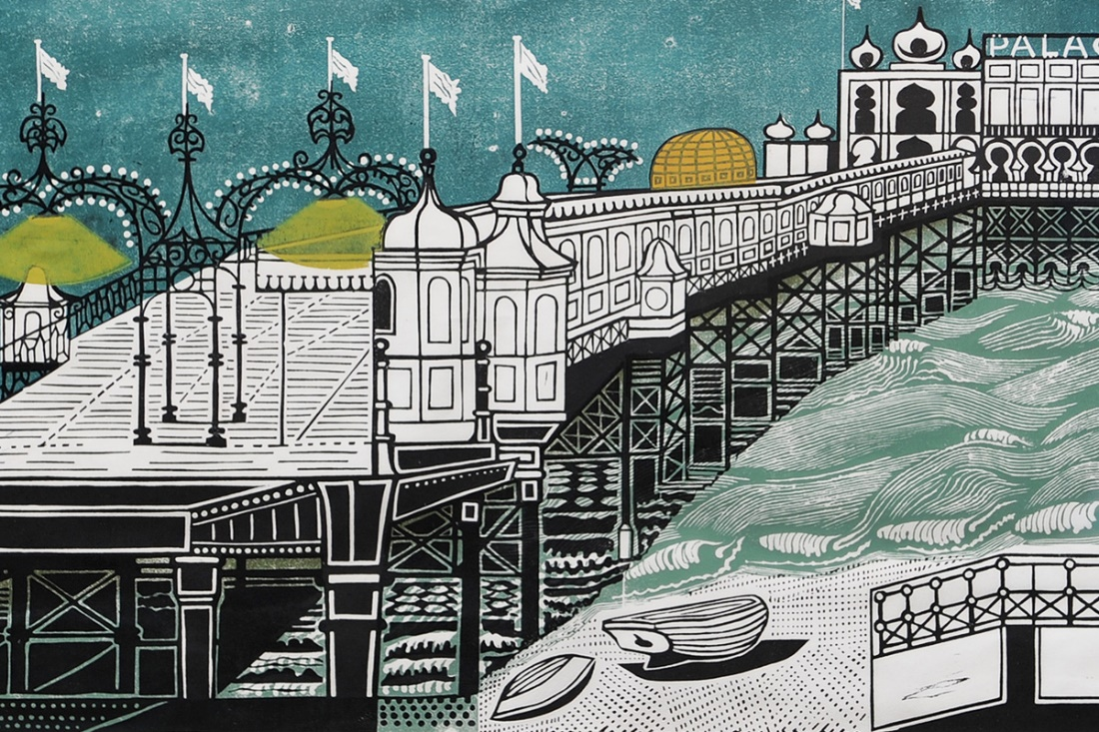

**Edward Bawden**